Design of a Hyperspectral Imager for Low-Earth Orbit small satellites

- First order System Specification

In this paper, we explored the design of a compact hyperspectral imager for Earth observation (vegetation monitoring). And to begin with the first order specification calculations, it is important to note that the imager is intended to fit into a 1.5U CubeSat form factor, capture images at an altitude of 500km (Sun Synchronous Orbit), and in the spectral range of 400-720nm. Several sensor types were considered but following an iterative theoretical calculation, we narrowed down to the CMV400, and JADE CMOS sensors. Considering the goal of the imager design, emphasis was placed on achieving the necessary spectral resolution essential for precise red-edge spectral sampling in advanced precision agriculture applications, while also considering cost to enhance accessibility to the technology.
Comparison was made between the Jade and the CMV4000 sensors. The Jade sensor is a relatively small sensor with a lower focal length compared to the CMV4000. With the Jade sensor, a GSD of 19.3m can be. However, a lower GSD of 6.9 which also means a better resolution can be obtained using the CMV4000 sensor. But after careful consideration and trade off studies including consultation with our industry partners, the Jade sensor was chosen as the candidate sensor for this design. This was due to several factors which included the large size of the CMV4000. The relay lens group requires several lenses to correct aberrations and the fore optics having a larger aperture could potentially increase the weight of the imager.

- System Design Process

Initial design and performance requirements were set, and the optical system is drafted based on these first-order specifications. Achieving an optimal design often requires multiple iterations, given the intricate relationships among various performance metrics [1]. In cases where balancing these metrics proves challenging, it may be necessary to refine the design through numerous iterations. As a final resort, one or more design requirements may need to be relaxed to prioritize meeting another, more critical requirement. This iterative process ensures that the final design strikes the best possible balance among competing objectives while fulfilling the most essential performance criteria. In the case of the proposed imager, SNR, MTF, GSD, were considered crucial design requirements while following the design iteration process as showing in fig. 2.1.
 | Specification
Design | Type A | Type B
Imager Typer | Pushbroom
Orbit Height | 500km (Sun Synchronous Orbit)
Spectral Range | 400 - 720nm
Sensor | CMV4000 | JADE
Pixel Size | 5.5μm | 5.8μm
Pixel Resolution | 2048 X 2048
FOV | 1.61⁰ (across track) | 1.86⁰ (across track)
 | 1.61⁰ (across track) | 1.42⁰ (across track)
 | 2.28⁰ (across track) | 2.33⁰ (across track)
Swath | 14.08km | 16.20km
Focal Length | 400mm | 150mm
GSD | 6.9 | 19.33mm
F/# | 6 | 6
Airy Disk Radius | 4.03μm at 550nm | 4.03μm at 550nm
Aperture | 66.7mm | 25mm
Obscuration | 32mm, 48% | 12mm, 48%
Distortion | <0.6% | <0.6%
On-Axis MTF | >0.3 at Nyquist (90.9 lp/mm) | >0.3 at Nyquist (86.2 lp/mm)
Slit Width | 50μm | 50μm
Spectral Separation | Transmission Grating (300 Grooves/mm) | Transmission Grating (300 Grooves/mm)
FWHM Bandwidth | 3.33nm | 3.33nm
SNR | 35 – 120 | 35 – 120
Volume | <1.5U | <1.5U
Mass | <1.5kg | <1.5kg
Table 1.1 Proposed Imager Specification
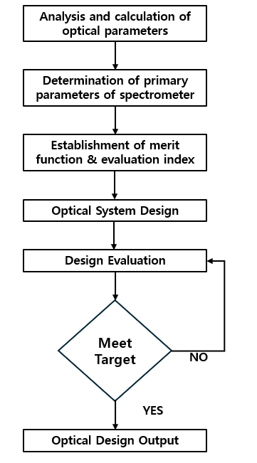

Figure 2.1 Flowchart of the design iteration process in engineering

2.1 Sensor Section
The Jade sensor was selected because of its innovative pixel design offers excellent performance in low-light conditions with an electronic global shutter and offers a high readout speed [2]. This makes it suitable for the application proposed in this study. Figure 2.2 shows the spectral response and quantum efficiency of the sensor.
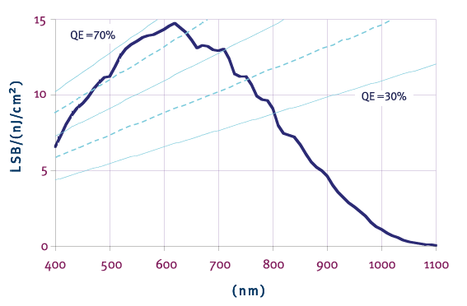

The sensor is highly efficient in the target spectral range of 400-700 nm. Additionally, the sensor specifications are highlighted in table 2.1 below.

Sensor Characteristics
Pixel resolution | 640 (V) X 838 (H) pixels
Pixel size | 5.8μm X 5.8μm
Image size | 1/2.9 inches
Aspect ratio | 4:3
Max frame rate | 60 @ full / 80 @ VGA fps
Pixel rate | 48 Mpixels/s
Pixel Performance
SNRmax | >40 dB
Responsivity | 15 LSB8/nj/${cm}^{2}$
Bit depth | 8 bits
Dynamic range | >52 (linear) / >100 (HDR)

Figure 2.2 Chosen Fore Optics Schematic

2.2 Working Principle
The structure of the hyperspectral imager is depicted in figure 2.2 below. The light collected from the fore optics passes though the slit and is collimated at $(L_{1})$ before hitting with transmission grating (G) and considering energy efficiency as a top priority, low groove densities of 300 grooves/mm were chosen. The transmission grating separates the spectrum and focuses the different spectrum on the detector (D)
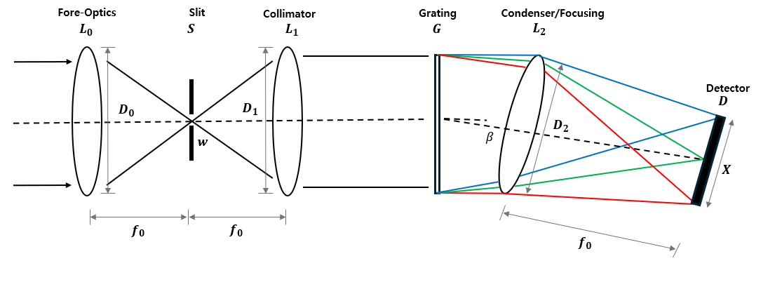
Figure 2.2 Chosen Spectrometer Schematic

3. Optical Layout
3.1 Fore Optics Design
The fore optics is a simple catadioptric Cassegrain telescope which utilizes two distinct mirrors: one concave and one convex. Positioned at the base of the telescope tube, the primary mirror is parabolic in shape with a central opening. Meanwhile, the secondary mirror, which is hyperbolic and convex, is smaller in size and placed near the top of the tube, within the focal point of the primary mirror [3]. But as illustrated in Fig. 3.1a, the image plane of a Cassegrain telescope typically lies behind the primary reflector, facilitating the installation of sensors or eyepieces. However, in this payload system, re-imaging is necessary to incorporate hyperspectral imaging capabilities (spectrometer), and there is a constraint on system overall length. Therefore, as depicted in Fig. 3.1b, the image plane is repositioned inside the telescope, specifically between the primary and secondary reflectors. This arrangement allows the collimator to be placed internally, further reducing the overall system length.
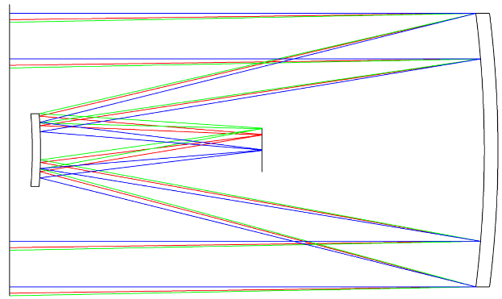
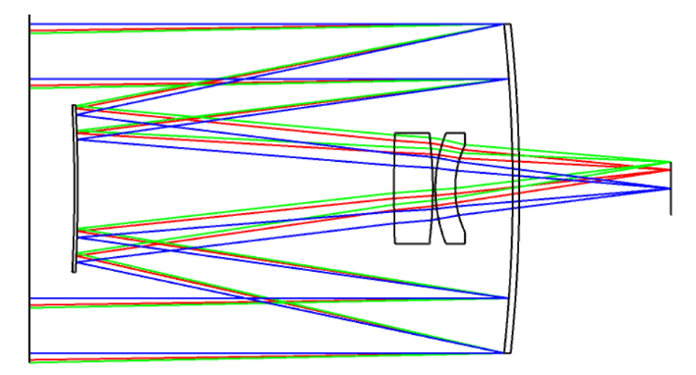
(a) External image plane (b) Internal image plane
Fig.3.1 Cassegrain telescope layout

However, this alteration introduces some drawbacks. Specifically, the available space between the image plane and the secondary reflector is decreased, preventing the insertion of correction lens. Consequently, the system cannot achieve diffraction-limited image quality, and any residual aberrations must instead be compensated for by the collimator lens assembly.

  - The collimator lens group
The role of the collimator lens group is to transform the image formed by the fore-optics into parallel rays before directing them onto the grating. In this paper, the collimator lens group additionally corrects residual aberrations originating from the fore-optics.
An appropriate initial lens structure is chosen based on experience, and an idealized lens replaces the condenser in the initial layout. The optimized arrangement of the lens group is illustrated in Fig. 3.2

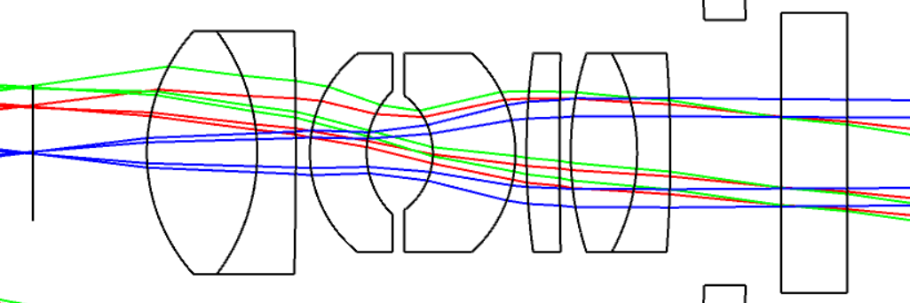

Fig.3.2 Collimator lens group layout

3.3 Spectrometer design (Condenser lens group)
The fore-optics consist of a reflective telescope, which exhibits polarization sensitivity. To prevent exacerbating this sensitivity, a transmission diffraction grating is employed. Since maximizing energy efficiency is critical, a diffraction grating with a low groove density of 300 grooves/mm is selected. The spectrometer design consists of a planar-type transmission grating element and a condenser lens group. The condenser lens group's purpose is to refocus the dispersed spectra onto the image sensor. During optimization, particular attention should be given to the angles at which different fields of view (FOV) strike the sensor. Ideally, the rays should arrive as perpendicular as possible, meaning the lens group should be designed to be telecentric. The layout of the spectrometer can be seen in Fig 3.3 below

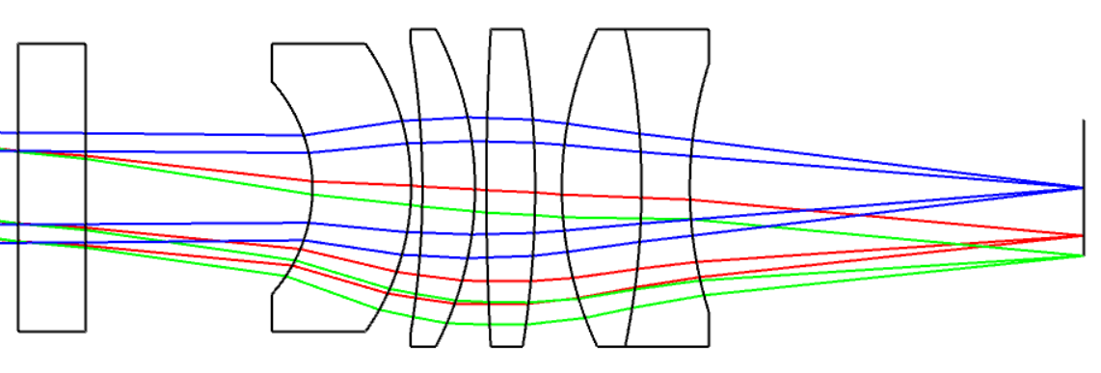

Fig.3.3 Condenser lens group layout

3.4 System Matching
Ensuring a seamless integration between the fore optics and spectrometer entails aligning the output rays of the former with the input rays of the latter at their connection plane. Ideally, this alignment would occur without compromising the individual image quality of each system. However, achieving this ideal scenario is impractical. Instead, in practice, certain first-order quantities are matched as an approximation of perfect alignment. There are several types of system matching that were considered some of which are F-number match at an internal image, pupil match in the space of collimation, perfect match for every ray, and F-number and chief ray match in a general internal image[1].
In this optical system, the connection plane is located at an internal image plane of the entire system and is telecentric in both systems, matching the F-number or numerical aperture can establish a first-order match, as depicted in Figure 3.4

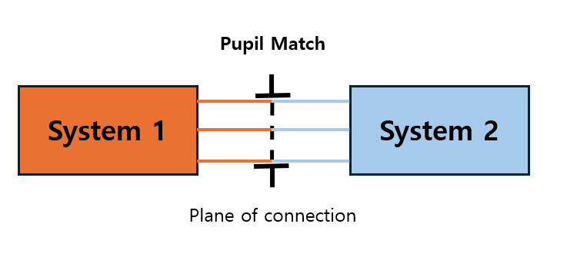

Fig.3.4 Pupil match in the space of collimation schematic

3.5 Combined System Optimization
After aligning the two subsystems, joint optimization was performed using Zemax. The three optical lens groups were integrated and re-optimized to establish the final optical configuration, as illustrated in Fig. 3.5. Among the optical components, only the primary reflector is parabolic, while the remaining lenses are spherical. The overall length from the secondary reflector to the sensor is kept below 115 mm. The system achieves a modulation transfer function (MTF) greater than 0.4 at the Nyquist frequency of 86.2 lp/mm. The maximum distortion is 1.04%, appearing at the marginal field of view (FOV). Additionally, the largest angle of incidence at the image plane is 0.8 degrees, also occurring at the marginal FOV.
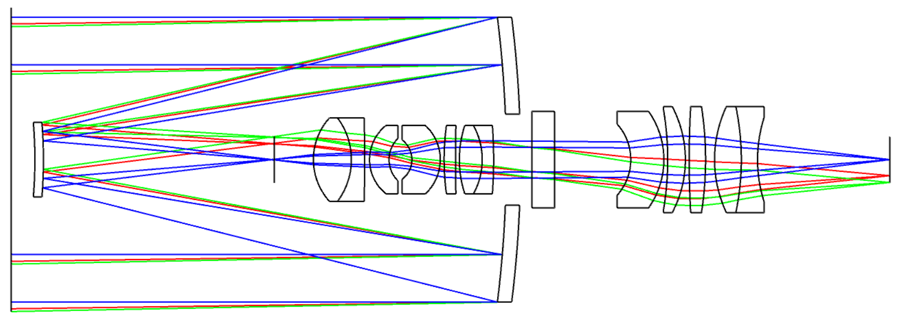
Fig. 3.5 Final System layout

The collimator and condenser lens groups constitute a 4-f optical system. To avoid any resolution loss, their focal lengths must be identical, resulting in a total length of four times the chosen focal length. A focal length of 20 mm was selected, making the distance from the slit to the sensor 80 mm. Including the telescope, the complete system length complies with the 150 mm design constraint. Additionally, to prevent energy loss, the F-number (F/#) of the lens groups should not exceed that of the telescope; thus, an F/# of 4 was adopted.

Extra Photos

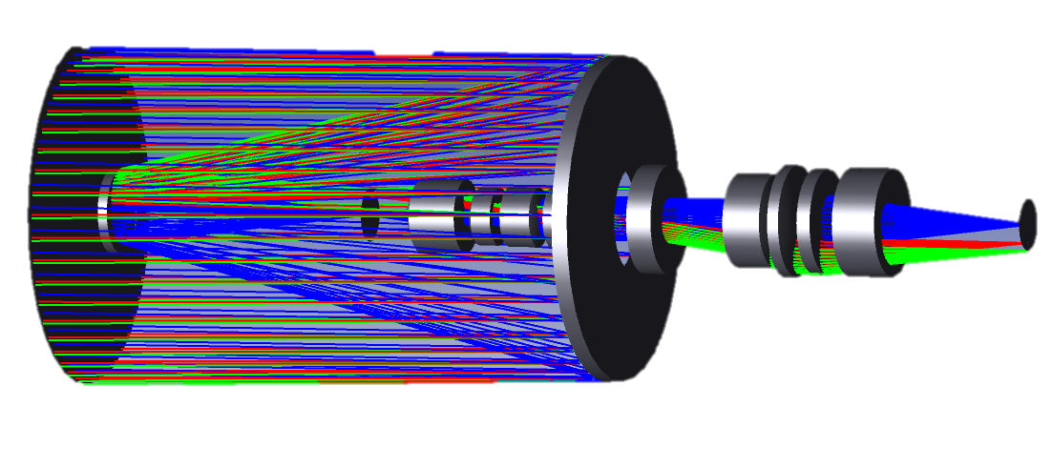

REFERENCE
[1] C. Joseph Middleton, “A Holistically Designed Hyperspectral Imager For CubeSats,” 2022.
[2] Ö. Karci, “A simulation and experimental validation of third-order coma in nodal aberrationtheory with a Cassegrain telescope,” Turkish Journal of Physics, vol. 45, no. 6, pp. 378–389, 2021, doi: 10.55730/1300-0101.1002.

